SQL commands

what is SQL commands
# Source: AI Source: Provided by: [Data Path: Persons Table -> ID Column: 1, Name_En Column: Motasem Essam] -> From: [ChatGPT] on [6/11/2026]
SQL (Structured Query Language) commands are instructions used to communicate with and manipulate databases. These commands let you perform tasks such as creating tables, inserting data, updating records, and retrieving data from a database.

what is sql commands types
# Source: AI Source: Provided by: [Data Path: Persons Table -> ID Column: 1, Name_En Column: Motasem Essam] -> From: [ChatGPT] on [6/11/2026]
SQL commands are grouped into five main types, based on what they do.
SQL commands are grouped into several main categories based on their purpose
Here's a breakdown of the different types of SQL commands:

1. 🔷 DML – Data Manipulation Language
# Source: AI Source: Provided by: [Data Path: Persons Table -> ID Column: 1, Name_En Column: Motasem Essam] -> From: [ChatGPT] on [6/11/2026]
Used to manipulate data inside tables.
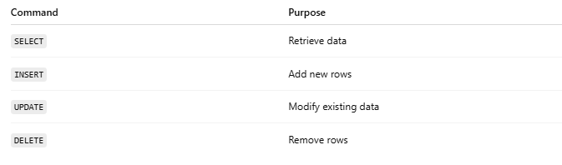
Command | Purpose
SELECT | Retrieve data
INSERT | Add new rows
UPDATE | Modify existing data
DELETE | Remove rows

Example. Data Manipulation Language (DML)
# Source: AI Source: Provided by: [Data Path: Persons Table -> ID Column: 1, Name_En Column: Motasem Essam] -> From: [ChatGPT] on [6/11/2026]
Used to manipulate data in tables:
- INSERT – Adds new records.
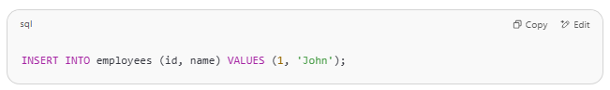
INSERT INTO employees (id, name) VALUES (1, 'John');

- UPDATE – Modifies existing records.
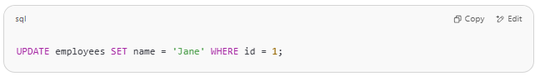
UPDATE employees SET name = 'Jane' WHERE id = 1;

- DELETE – Removes records.
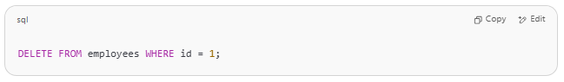
DELETE FROM employees WHERE id = 1;

2. 🔷 DDL – Data Definition Language
# Source: AI Source: Provided by: [Data Path: Persons Table -> ID Column: 1, Name_En Column: Motasem Essam] -> From: [ChatGPT] on [6/11/2026]
Used to define or modify the structure of database objects like tables.
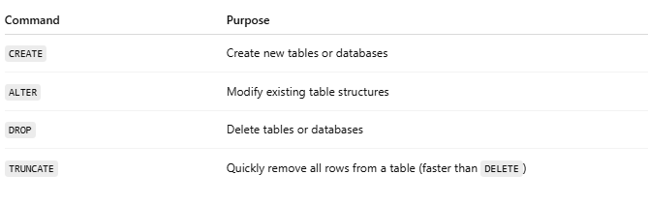
Command | Purpose
CREATE | Create new tables or databases
ALTER | Modify existing table structures
DROP | Delete tables or databases
TRUNCATE | Quickly remove all rows from a table (faster than DELETE)

Example Data Definition Language (DDL)
# Source: AI Source: Provided by: [Data Path: Persons Table -> ID Column: 1, Name_En Column: Motasem Essam] -> From: [ChatGPT] on [6/11/2026]
Used to define and modify database structures (schemas, tables, etc.):
- CREATE – Creates a new database object (like a table).
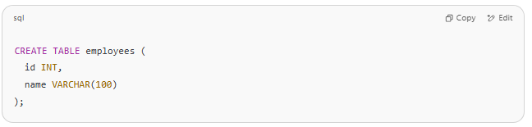
CREATE TABLE employees (
id INT,
name VARCHAR(100)
);

- ALTER – Modifies an existing database object.
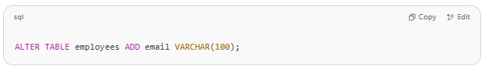
ALTER TABLE employees ADD email VARCHAR(100);

- DROP – Deletes a database object.
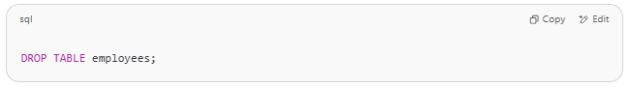
DROP TABLE employees;

3. 🔷 DCL – Data Control Language
# Source: AI Source: Provided by: [Data Path: Persons Table -> ID Column: 1, Name_En Column: Motasem Essam] -> From: [ChatGPT] on [6/11/2026]
Used to control access and permissions.
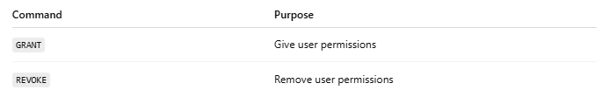
Command | Purpose
GRANT | Give user permissions
REVOKE | Remove user permissions

Example Data Control Language (DCL)
# Source: AI Source: Provided by: [Data Path: Persons Table -> ID Column: 1, Name_En Column: Motasem Essam] -> From: [ChatGPT] on [6/11/2026]
Used to control access to data:
- GRANT – Gives user access privileges.
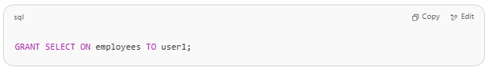
GRANT SELECT ON employees TO user1;

- REVOKE – Removes access privileges.
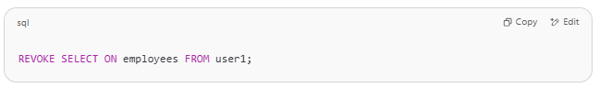
REVOKE SELECT ON employees FROM user1;

4. 🔷 TCL – Transaction Control Language
# Source: AI Source: Provided by: [Data Path: Persons Table -> ID Column: 1, Name_En Column: Motasem Essam] -> From: [ChatGPT] on [6/11/2026]
Manages transactions (grouped SQL operations that must succeed or fail together).
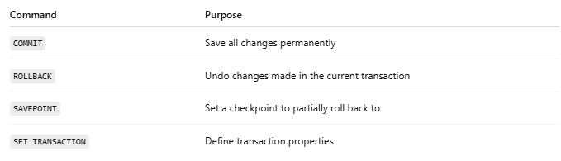
Command | Purpose
COMMIT | Save all changes permanently
ROLLBACK | Undo changes made in the current transaction
SAVEPOINT | Set a checkpoint to partially roll back to
SET TRANSACTION | Define transaction properties

Example Transaction Control Language (TCL)
# Source: AI Source: Provided by: [Data Path: Persons Table -> ID Column: 1, Name_En Column: Motasem Essam] -> From: [ChatGPT] on [6/11/2026]
Manages changes made by DML commands:
- COMMIT – Saves all changes made in the current transaction.
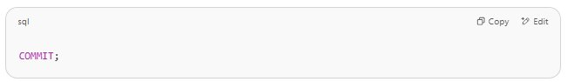
COMMIT;

- ROLLBACK – Reverts changes made in the current transaction.
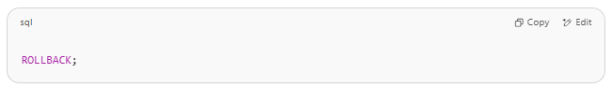
ROLLBACK;

- SAVEPOINT – Sets a save point within a transaction.
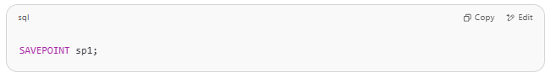
SAVEPOINT sp1;

5. 🔷 DQL – Data Query Language (sometimes listed separately)
# Source: AI Source: Provided by: [Data Path: Persons Table -> ID Column: 1, Name_En Column: Motasem Essam] -> From: [ChatGPT] on [6/11/2026]
Focused only on querying data.
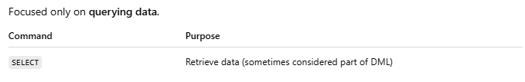
Command | Purpose
SELECT | Retrieve data (sometimes considered part of DML)

Example. Data Query Language (DQL)
# Source: AI Source: Provided by: [Data Path: Persons Table -> ID Column: 1, Name_En Column: Motasem Essam] -> From: [ChatGPT] on [6/11/2026]
Used to query data:
SELECT – Retrieves data from one or more tables.
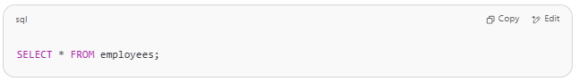
SELECT * FROM employees;

✅ Summary Table:
# Source: AI Source: Provided by: [Data Path: Persons Table -> ID Column: 1, Name_En Column: Motasem Essam] -> From: [ChatGPT] on [6/11/2026]
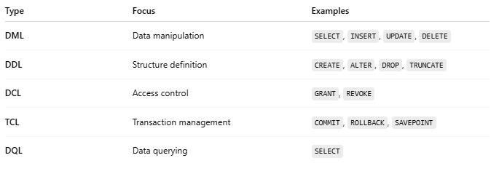
Type | Focus | Examples
DML | Data manipulation | SELECT, INSERT, UPDATE, DELETE
DDL | Structure definition | CREATE, ALTER, DROP, TRUNCATE
DCL | Access control | GRANT, REVOKE
TCL | Transaction management | COMMIT, ROLLBACK, SAVEPOINT
DQL | Data querying | SELECT

Let me know if you want examples of each with real table data!

give me orders of them of must i learn first
# Source: AI Source: Provided by: [Data Path: Persons Table -> ID Column: 1, Name_En Column: Motasem Essam] -> From: [ChatGPT] on [6/11/2026]
Great question! If you're starting to learn SQL, it's best to follow a logical progression from the most foundational commands to the more advanced ones.
Here’s a recommended learning order:

✅ 1. DQL – Start with SELECT
# Source: AI Source: Provided by: [Data Path: Persons Table -> ID Column: 1, Name_En Column: Motasem Essam] -> From: [ChatGPT] on [6/11/2026]
This is the heart of SQL and what you'll use most often to read data.
- SELECT, FROM, WHERE
- ORDER BY, LIMIT
- DISTINCT
- Basic filtering and conditions (=, >, <, AND, OR, LIKE, IN, BETWEEN)
👉 Why first? You need to learn how to read data before doing anything else.

✅ 2. DML – Learn how to modify data
# Source: AI Source: Provided by: [Data Path: Persons Table -> ID Column: 1, Name_En Column: Motasem Essam] -> From: [ChatGPT] on [6/11/2026]
Once you know how to view data, learn how to manipulate it.
- INSERT INTO – Add new records
- UPDATE – Modify existing data
- DELETE – Remove data
👉 Why second? After you can read data, you’ll want to learn how to change it.

✅ 3. DDL – Learn how to structure the database
# Source: AI Source: Provided by: [Data Path: Persons Table -> ID Column: 1, Name_En Column: Motasem Essam] -> From: [ChatGPT] on [6/11/2026]
Now learn how to create and change tables and structures.
- CREATE TABLE
- ALTER TABLE
- DROP TABLE
👉 Why third? You’ll eventually need to create your own tables to work with data.

✅ 4. Clauses and Joins – Intermediate SELECT
# Source: AI Source: Provided by: [Data Path: Persons Table -> ID Column: 1, Name_En Column: Motasem Essam] -> From: [ChatGPT] on [6/11/2026]
Expand your SELECT knowledge to multiple tables and complex queries.
- JOIN (INNER, LEFT, RIGHT, FULL)
- GROUP BY, HAVING
- AS (aliasing), UNION, SUBQUERIES
👉 Why now? This gives you power to analyze data across tables.

✅ 5. TCL – Learn about transactions (optional at first)
# Source: AI Source: Provided by: [Data Path: Persons Table -> ID Column: 1, Name_En Column: Motasem Essam] -> From: [ChatGPT] on [6/11/2026]
If you’re working with applications or need safe data changes:
- BEGIN, COMMIT, ROLLBACK, SAVEPOINT
👉 Why later? Useful for managing big changes safely, mostly in apps.

✅ 6. DCL – Control user access (optional for most beginners)
# Source: AI Source: Provided by: [Data Path: Persons Table -> ID Column: 1, Name_En Column: Motasem Essam] -> From: [ChatGPT] on [6/11/2026]
- GRANT, REVOKE
👉 Why last? You typically won’t deal with permissions early on.

✅ Summary Order to Learn:
# Source: AI Source: Provided by: [Data Path: Persons Table -> ID Column: 1, Name_En Column: Motasem Essam] -> From: [ChatGPT] on [6/11/2026]
- SELECT (DQL)
- INSERT, UPDATE, DELETE (DML)
- CREATE, ALTER, DROP (DDL)
- JOIN, GROUP BY, HAVING, SUBQUERIES
- Transactions: COMMIT, ROLLBACK (TCL)
- Permissions: GRANT, REVOKE (DCL)

